Ex.no:9 | MINI PROJECT – SOCIAL MEDIA  DATA ANALYTICS

Domain and Problem Statement:
Domain: Social Media Analytics & Digital Marketing
Problem Statement: Instagram accounts face challenges in maintaining consistent engagement, maximizing content reach, and identifying effective content strategies across different media types, posting times, and audience segments. This project addresses these challenges by transforming raw Instagram post records into structured business intelligence across Power BI and Tableau to evaluate content performance, engagement trends, audience reach, and high-performing content strategies.

Dataset Description:
Dataset Name: Instagram Analytics Dataset.
Granularity: Each row represents a single Instagram post record.
Timeframe Covered: 2024 to 2025.
Key Entities & Attributes:
- Account Details: account_id, account_type, follower_count.
- Content Details: media_type, content_category, traffic_source, has_call_to_action, caption_length, hashtags_count.
- Posting Details: post_datetime, post_date, post_hour, day_of_week.
- Engagement Metrics: likes, comments, shares, saves, engagement_rate.
- Performance Metrics: reach, impressions, followers_gained, performance_bucket_label.
Data Source:
Primary Source: Kaggle Open Datasets (Instagram Analytics Dataset)
Storage Infrastructure: Cleaned Instagram post records hosted within a local MySQL database instance (instagram_analytics).

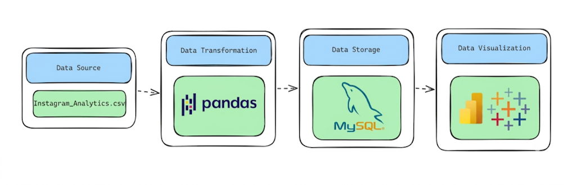
Architecture:
Program:
1. Python – Data Cleaning & Transformation
import pandas as pd
# Load dataset
df = pd.read_csv("Instagram_Analytics.csv")
# Create a copy for processing
instagram = df.copy()
# Standardize column names
instagram.columns = (
instagram.columns
.str.lower()
.str.strip()
.str.replace(" ", "_")
)
# Clean text columns
text_columns = instagram.select_dtypes(include="object").columns
for col in text_columns:
instagram[col] = instagram[col].str.strip()
# Convert date and datetime columns
instagram["post_datetime"] = pd.to_datetime(
instagram["post_datetime"],
errors="coerce"
)
instagram["post_date"] = pd.to_datetime(
instagram["post_date"],
errors="coerce"
)
# Remove duplicate post records
instagram.drop_duplicates(
subset=["post_id"],
inplace=True
)
# Remove invalid negative values
non_negative_columns = [
"follower_count",
"likes",
"comments",
"shares",
"saves",
"reach",
"impressions",
"followers_gained",
"caption_length",
"hashtags_count"
]
for col in non_negative_columns:
instagram = instagram[
instagram[col] >= 0
]
# Ensure CTA values are binary
instagram = instagram[
instagram["has_call_to_action"].isin([0, 1])
]

# Remove records with invalid dates
instagram.dropna(
subset=["post_datetime", "post_date"],
inplace=True
)
# Reset index
instagram.reset_index(drop=True, inplace=True)
print("Original Shape:", df.shape)
print("Cleaned Shape:", instagram.shape)
instagram.head()
2. MySQL – Database and Data Loading
MySQL Command Prompt:
net start MySQL80
mysql -u root -p
MySQL:
CREATE DATABASE IF NOT EXISTS instagram_analytics;
Python/Jupyter:
username = "root"
password = "YOUR_MYSQL_PASSWORD"
host = "localhost"
port = 3306

# Connect to MySQL database
db_engine = create_engine(
f"mysql+pymysql://{username}:{password}@{host}:{port} /instagram_analytics"
)

# Load cleaned data into MySQL
instagram.to_sql(
"instagram_posts",
con=db_engine,
if_exists="replace",
index=False,
chunksize=5000
)
print("Data loaded successfully into MySQL.")
Verify:
pd.read_sql(
" SELECT COUNT(*) AS total_rows FROM instagram_posts",
db_engine
)

Procedure:
Step 1: Data Preparation & Preprocessing (Python / Pandas)
- Load the raw Kaggle Instagram Analytics Dataset into a Jupyter Notebook / Python script using pandas.read_csv().
- Inspect the dataset for null values and duplicate records, clean text fields, and convert post_datetime and post_date into appropriate datetime formats.
- Validate engagement and audience metrics such as follower count, likes, comments, shares, saves, reach, impressions, and followers gained by removing invalid negative values.
- Export the cleaned DataFrame to the local MySQL database instagram_analytics using SQLAlchemy and to_sql(), storing the data in the instagram_posts table.
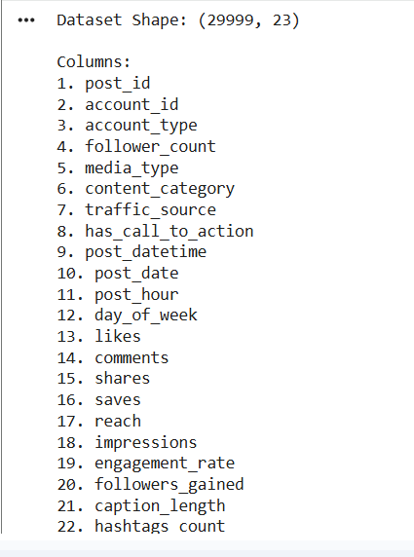

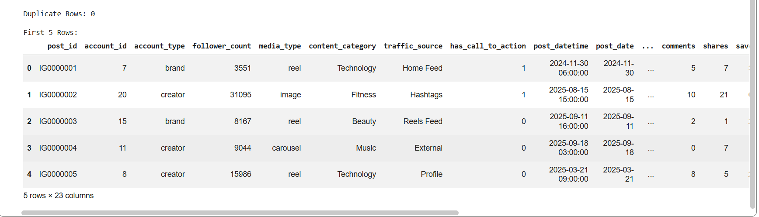
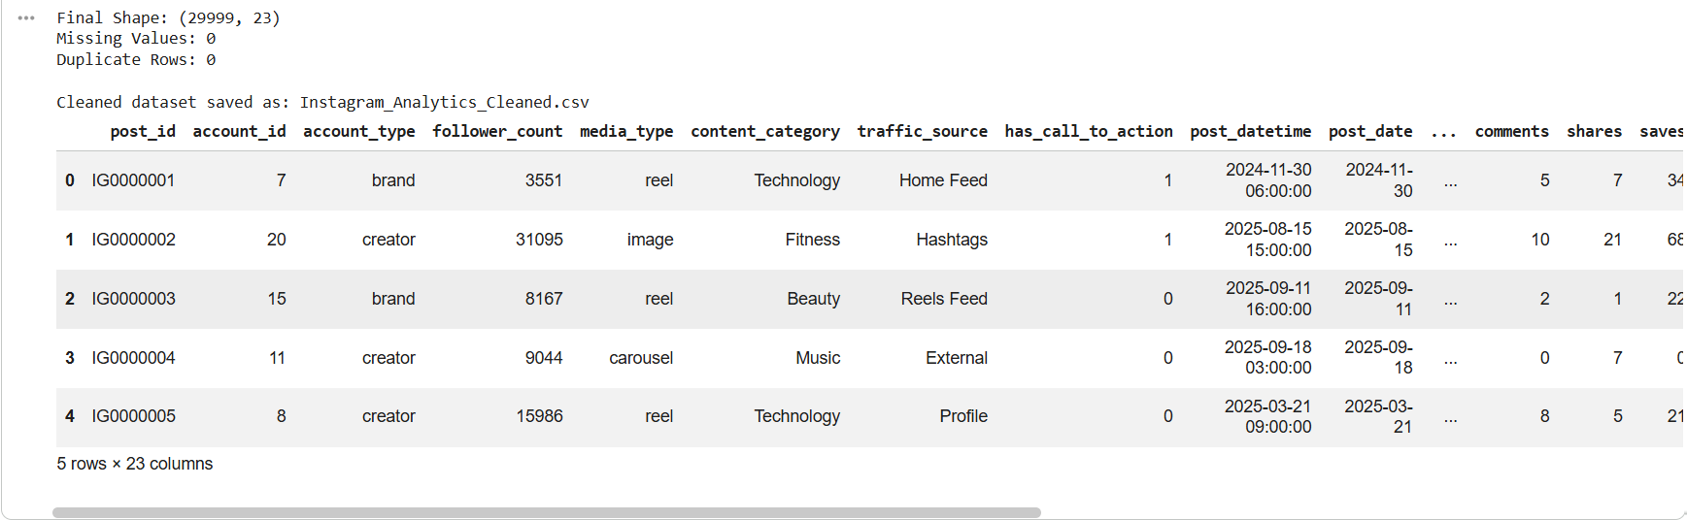

Step 2: SQL Database Connection & Data Ingestion
- Open Power BI Desktop $→$ Click Get Data $→$ Select MySQL Database.
- Enter the Server (localhost:3306) and Database Name (instagram_analytics).
- Enter authentication credentials, select the cleaned flat table (Instagram_analytics / Instagram_posts), and click Transform Data to open Power Query
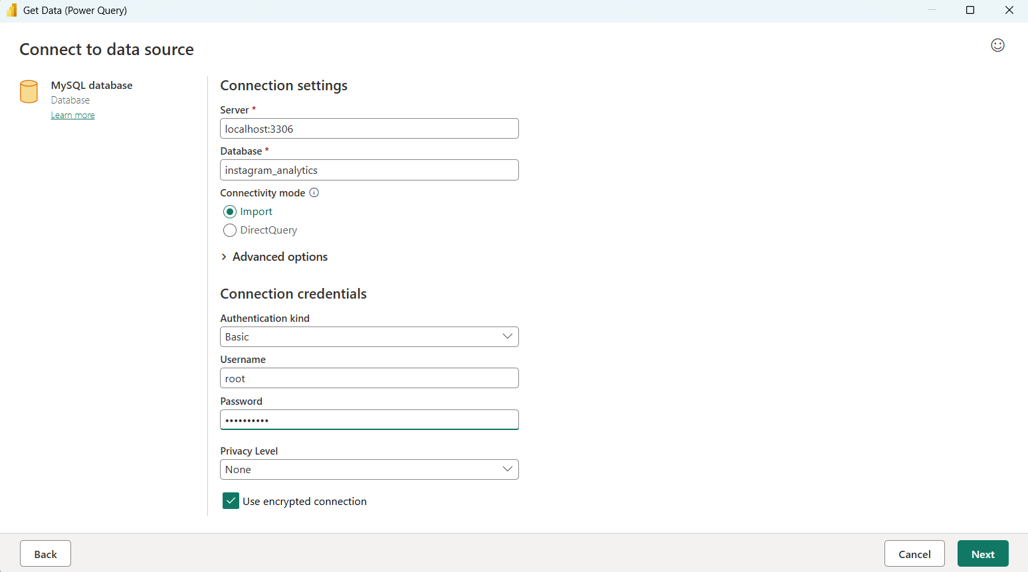
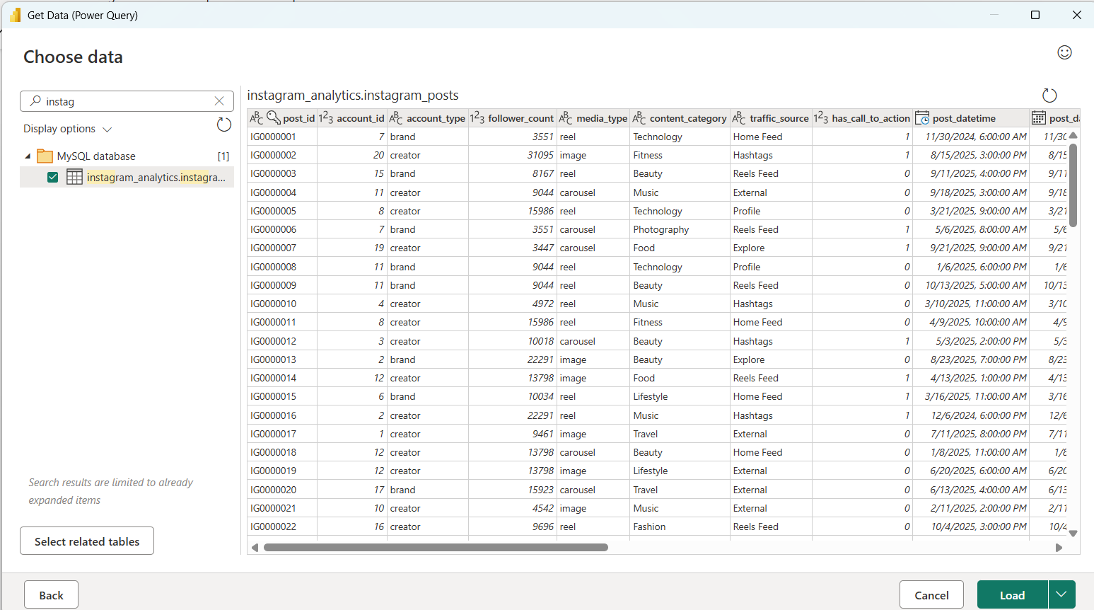

Step 3: Star Schema Data Modeling (Power BI)
- Table Splitting in Power Query:
  - Connect the cleaned instagram_posts table from the MySQL database instagram_analytics to Power BI.
  - Use Power Query to verify data types, remove blank rows if any, and ensure text and date fields are properly formatted.
  - Create a separate DateTable using DAX with Year, Quarter, Month, and Day attributes.
  - Establish a relationship between DateTable[Date] and instagram_posts[post_date].
  - Create a one-to-many relationship with DateTable as the dimension and instagram_posts as the fact table.
  - Click Close & Apply to load the transformed data into the Power BI mode.
  - Click Close & Apply.
- Establishing Relationships in Model View:
  - Open the Model View tab in Power BI.
  - Connect DateTable[Date] → instagram_posts[post_date].
  - Set the relationship as One-to-Many (1:*), with DateTable on the one side.
  - Use the DateTable fields for time-based analysis such as Year, Quarter, Month, and Day.
  - Keep the model organized by using the date dimension for all time-based visualizations and analysis..
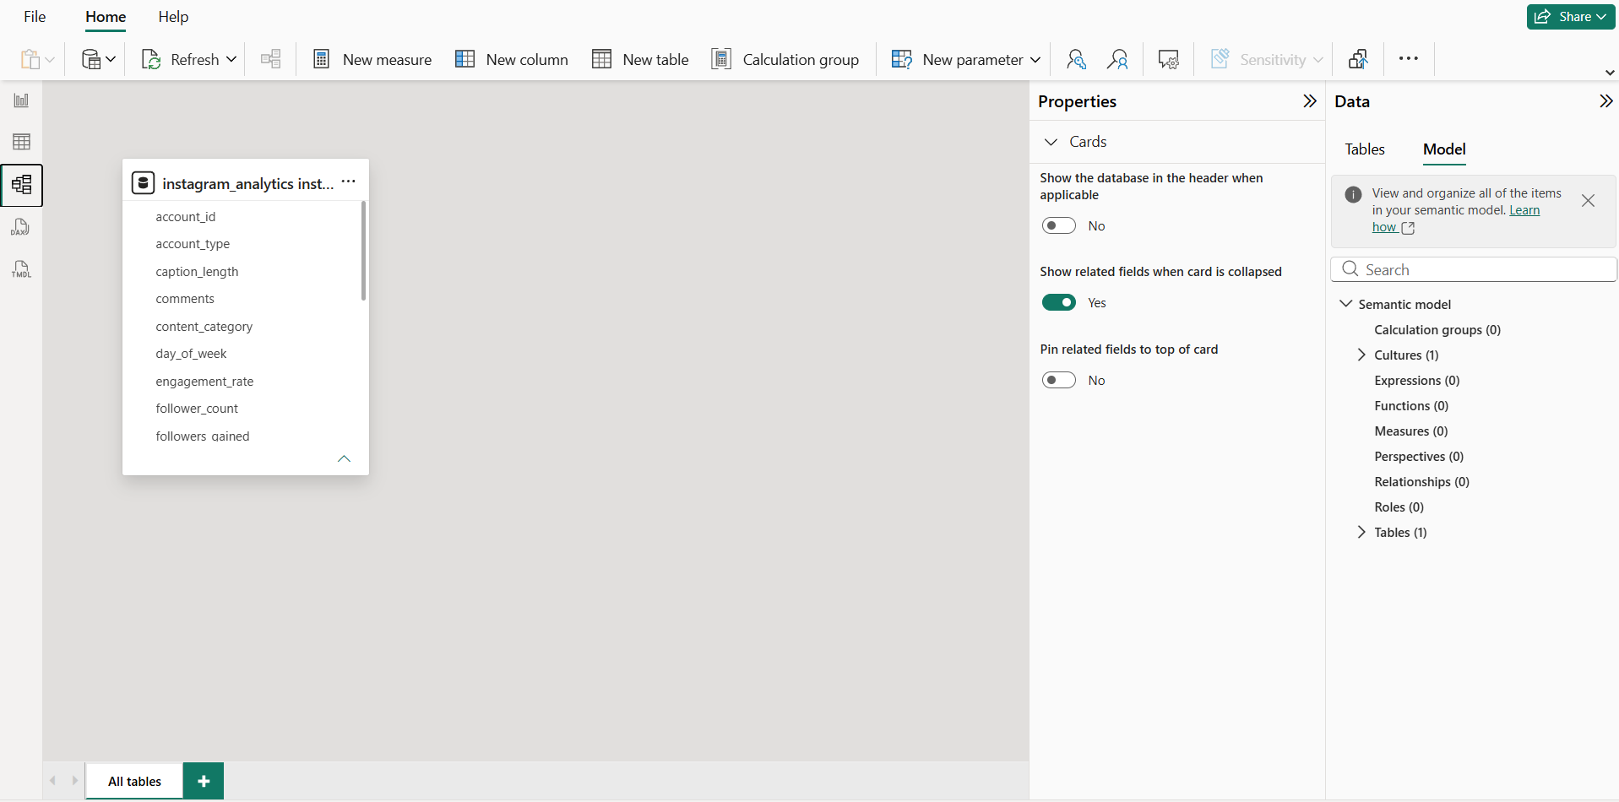

Step 4: Core Calculations & Measures (DAX)
Power BI Measures (DAX)
Create a dedicated _Measures table and add the following DAX calculations:
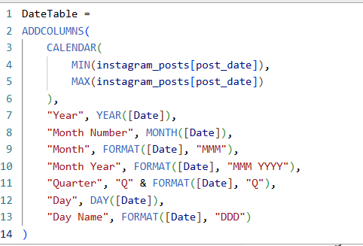
- DateTable:

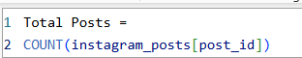
- Total Posts:

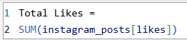
- Total Likes:

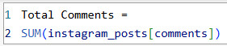
- Total Comments:

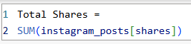
- Total Shares:

Step 5: Power BI Final Executive Dashboard & Drill-Through
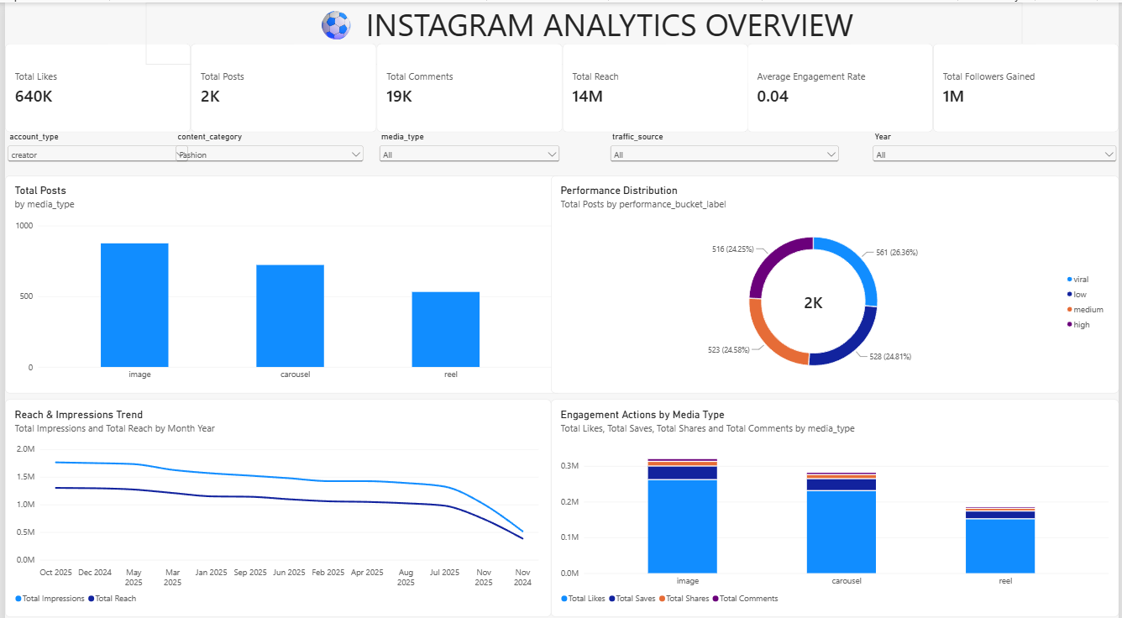
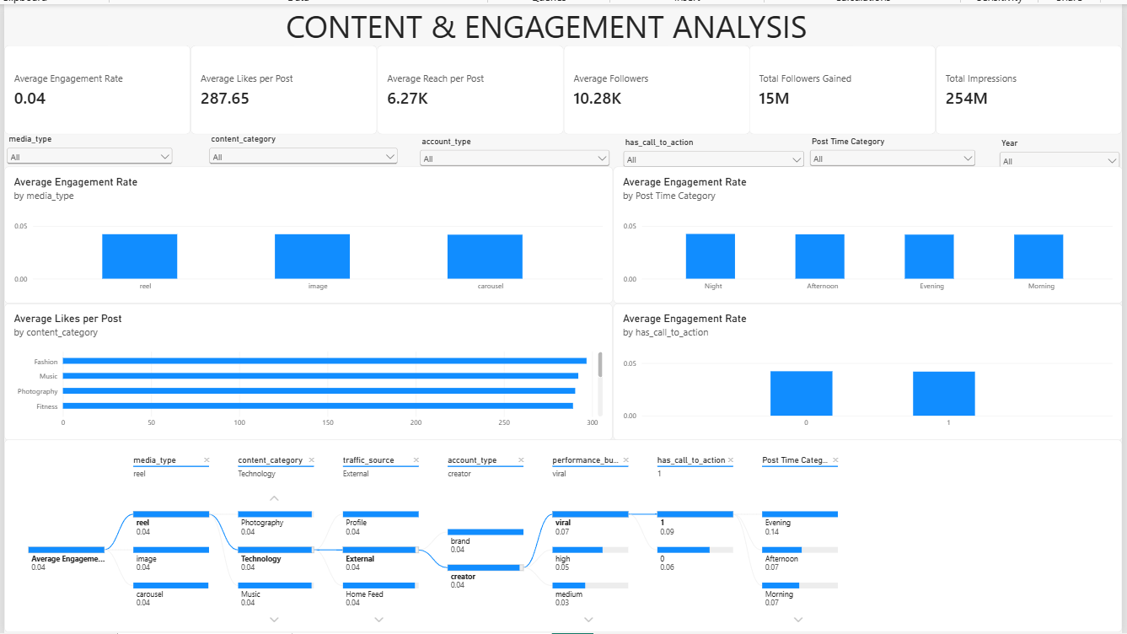

- Executive Canvas:
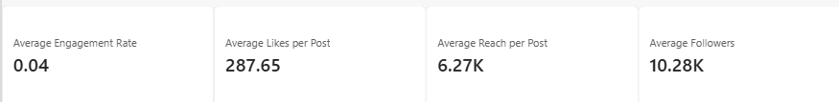
  - Place Card Visuals across the top: Average Engagement Rate, Average Likes per Post, Average Reach per Post, Average Followers.

  - Add a Line Chart mapped to Total Impressions with hierarchy drill-down enabled (Year $→$ Quarter $→$ Month).
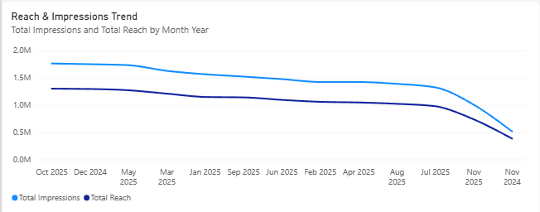

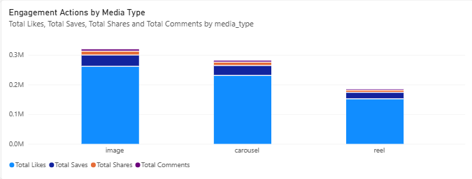
  - Add a Clustered Bar Chart for Engagement Actions by Media Type.

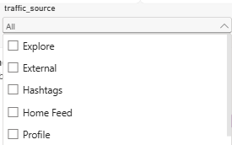
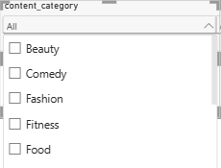
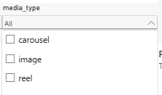
  - Add Slicers for media_type, content_category, traffic_source

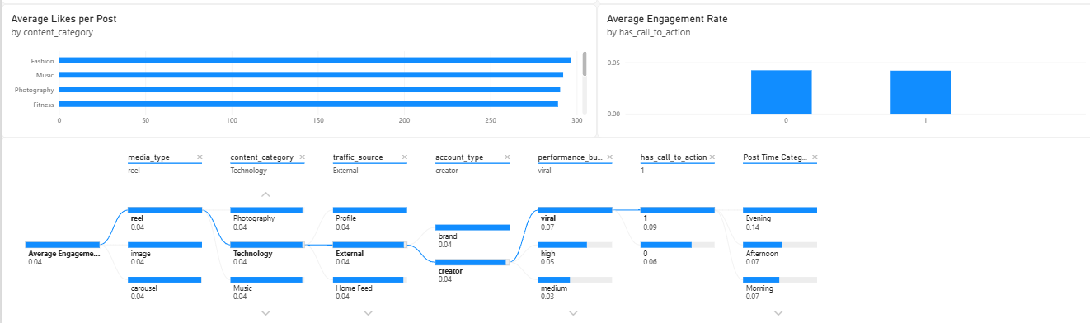
- Decomposition Tree :

Step 6: Tableau Data Connection & Preparation
- Open Tableau Desktop / Tableau Public.
- Under To a Server, select MySQL
- Enter Server (localhost), Database (instagram_analytics), and user credentials to pull the cleaned dataset onto the canvas.
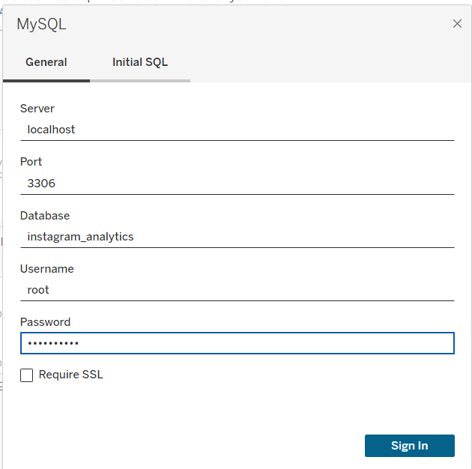

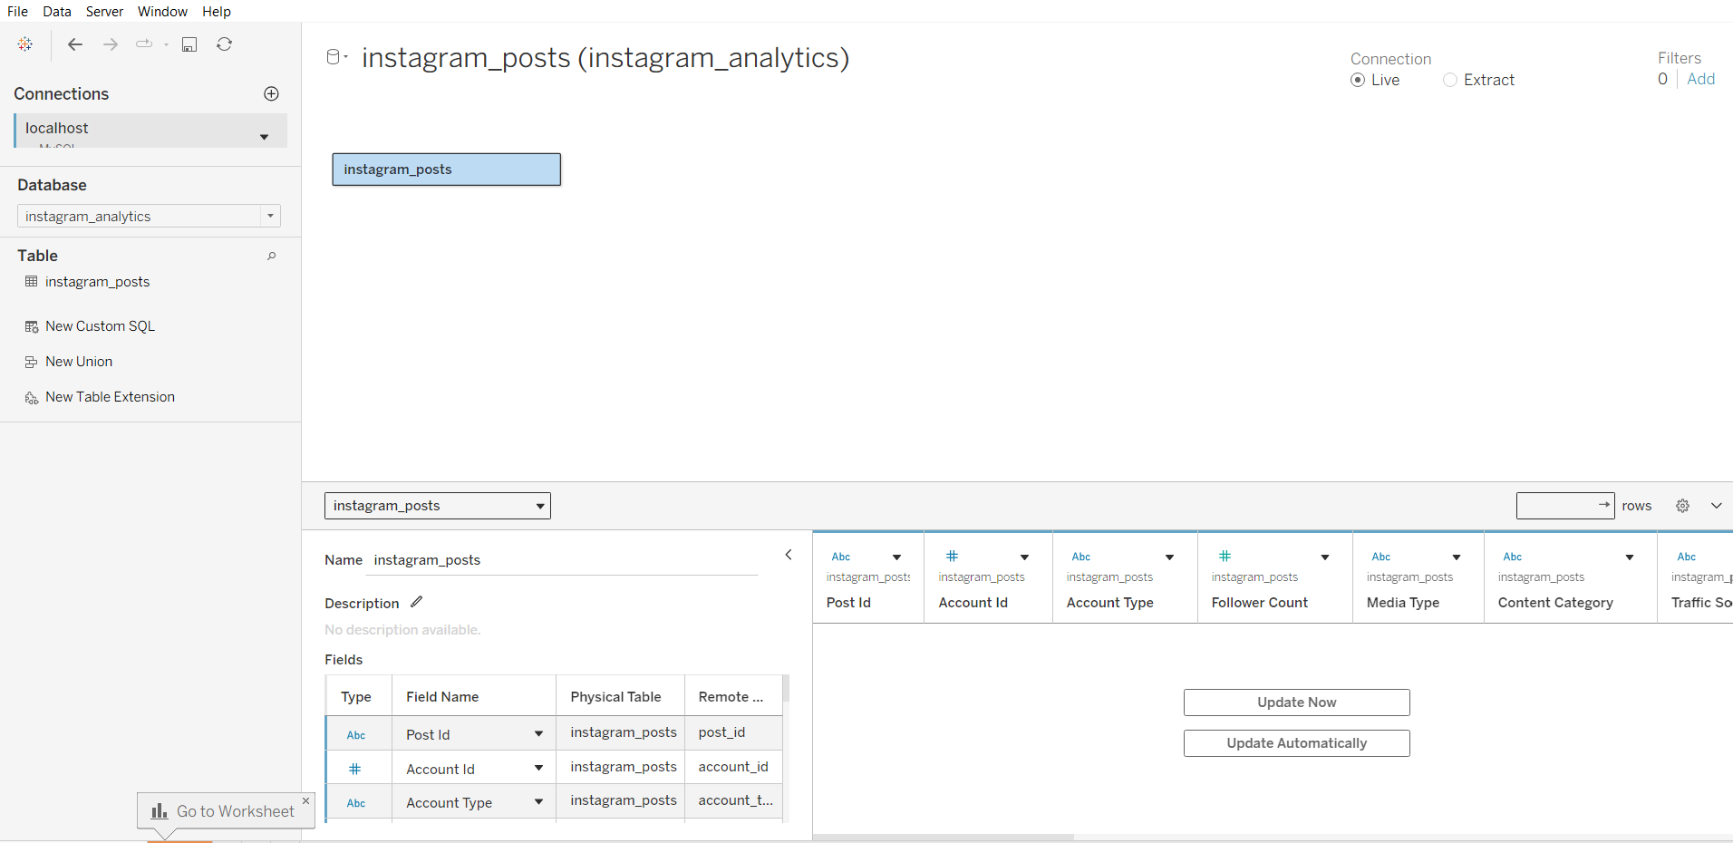

- Go to any sheet and build calculated fields:
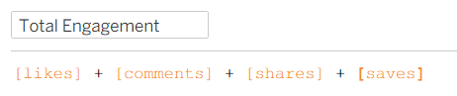
  - Total Engagement

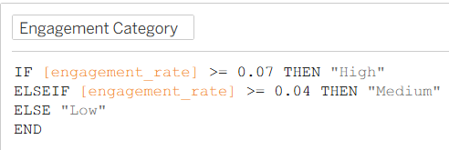
  - Engagement Category

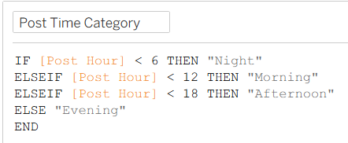
  - Total Bookings

  - Engagement Rate %
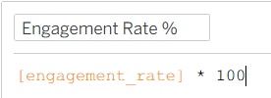

  - Select Metric Parameter: String list containing "Total Likes”, ”Total Comments”, ”Total Saves”, “Reach”.
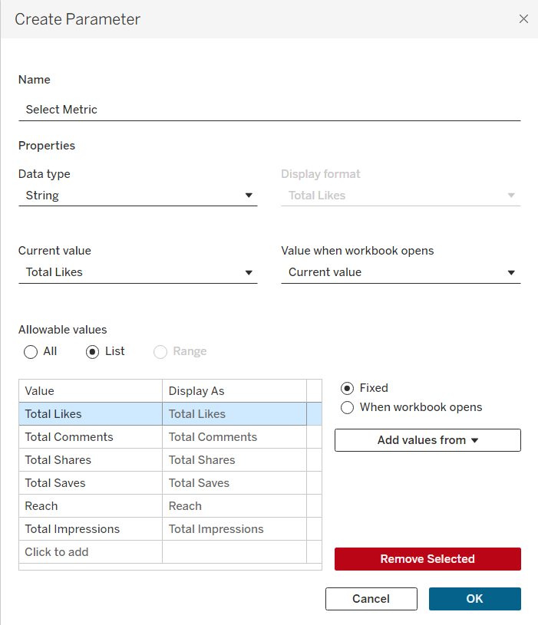

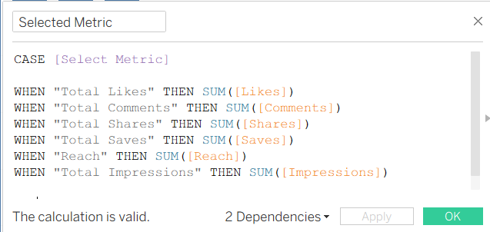
  - Selected Metric Formula:

Step 7: Tableau Companion Dashboard & Interactive Story
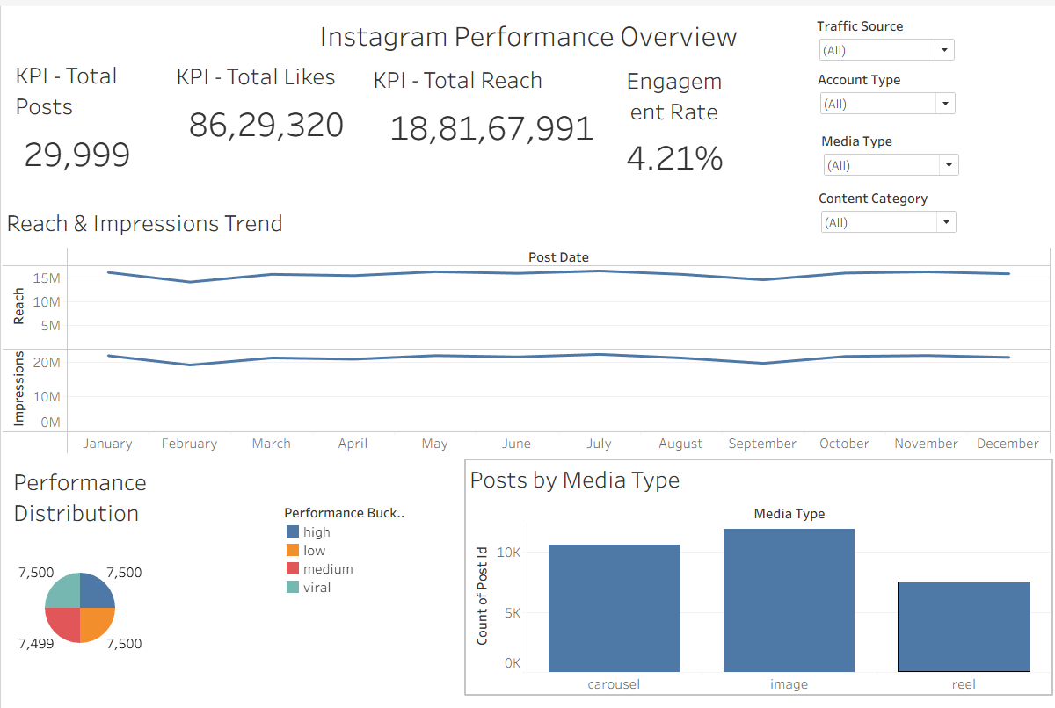

- Worksheets: Build KPI Cards, Revenue Trend Line Chart (using Dynamic Measure),
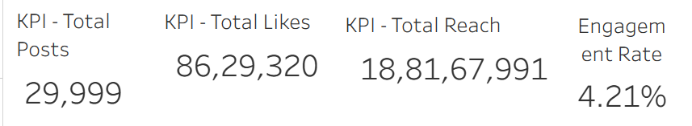

- Global Filters & Actions:
  - Drag traffic, media_type, content_category to Filters $→$ set to Apply to Worksheets $→$ All Using This Data Source.
  - Drag sheets onto a new Dashboard tab and click the Use as Filter funnel icon on the Country Map visual.
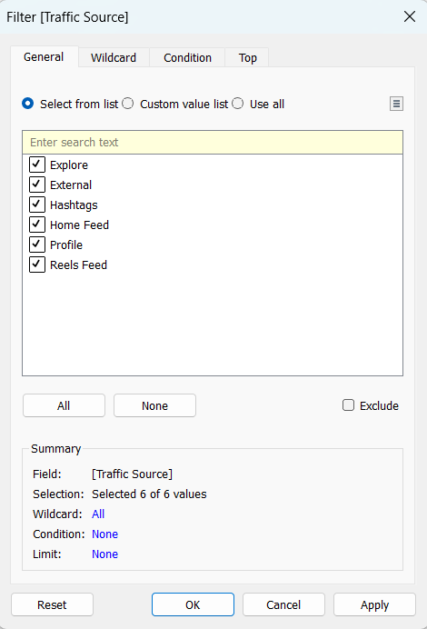

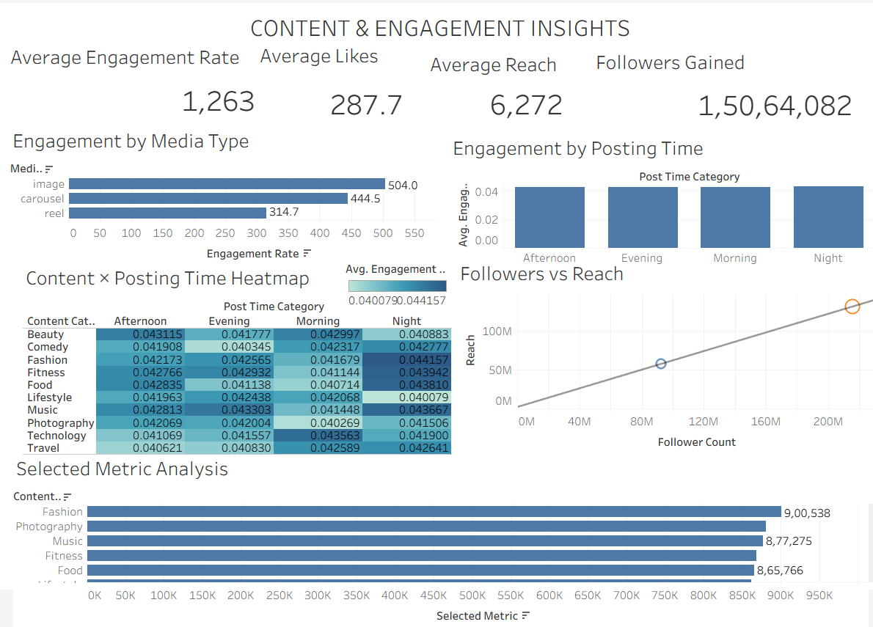
- Content and Engagement Insights :
Observed Insights:
- Overall Engagement & Post Volume: The dataset contains 29,999 Instagram Posts, providing a comprehensive view of content activity, audience reach, and engagement performance across different content categories and account types.
- Engagement Performance: Engagement varies across Media Types, Content Categories, and Account Types, allowing high-performing content formats and audience segments to be identified using likes, comments, shares, saves, and engagement rate.
- Posting Time Trends: Engagement performance changes across different posting time categories (Night, Morning, Afternoon, and Evening), helping identify time periods associated with stronger audience interaction.
- Audience & Content Performance: Follower Count, Reach, Impressions, and Followers Gained provide insights into how audience size and content characteristics influence Instagram performance, while traffic sources and calls-to-action help identify effective content strategies.

RESULT:
The Instagram Analytics mini project was successfully implemented using Python, MySQL, Power BI, and Tableau. An Instagram analytics dataset containing 29,999 post records was processed and cleaned using Python and stored in MySQL. The data was successfully analyzed and visualized using Power BI and Tableau through bar charts, line charts, pie charts, heatmaps, scatter plots, KPI cards, and interactive dashboards. The dashboards provide insights into content performance, engagement rates, audience reach, posting time, media types, traffic sources, and high-performing Instagram content.

Final Result:
Instagram Analytics Dataset
↓
Python Data Processing
↓
Cleaned CSV Dataset
↓
MySQL Database
↓
Data Verified
↓
Power BI & Tableau Connection
↓
Charts & Visualizations
↓
Interactive Dashboards
↓
Instagram Analytics Completed

CONCLUSION:
Thus, the Instagram Analytics dataset was successfully cleaned, stored, managed, analyzed, and visualized using Python, MySQL, Power BI, and Tableau. The project demonstrates how data analytics and visualization techniques can be used to evaluate Instagram engagement, content performance, audience reach, posting patterns, and performance trends and identify meaningful insights for effective social media strategies.

